**WIRELESS CONTROLLED SMART DIGITAL ENERGY METER AND THEFT CONTROL USING GSM WITH GUI**

**ABSTRACT**

In modern world intelligent control has become a priority, although the services for providing energy are still being controlled with conventional methods. The conventional method is expensive and time consuming as well as it requires man power for monitoring and data collection of the consumers which may also lead to human errors. The proposed GSM based system integrates digital energy meters installed at consumer unit with an electric supply companies to monitor, profile and control energy flow with the help of Graphical User Interface (GUI). In this two-way communication system, the GSM network is utilized to profile the energy flow with the help of SMS to the energy supplier and showing it on the monitor of the energy supplier using the GUI and can also communicate with the user via SMS. Relay circuit and LCD display is provided to update information like Voltage, Current, Units and billing or sudden power cut to the energy supplier company and is displayed on GUI. Now a day the main problem in energy supply is that of power theft being done on various scales. Our system can also send an alert to the energy supplier in case of any power theft at the consumer side and cutoff the supply automatically until the power theft is not being cleared. This research highlights the general theory of energy metering system and focuses on our user friendly low power energy metering system design, implementation, power theft control and results.

**INTRODUCTION**

In smart metering system as proposed in research with the ability to communicate wirelessly, commands are sent to the meter via SMS and the meter replies with the relevant energy consumption readings again via SMS. In this way it allows both the power supply companies and the user to have a better monitoring of the energy consumed by the load. Smart Energy has been an important conceptual paradigm for future energy use. How to make energy use more efficient and effective is very critical for future social and economic developments due to limited availability of non-renewable energy resources and expensive ways of acquiring renewable energies. Over the last few years, Smart Energy Meter has been proposed as an innovative solution aimed at facilitating affordability and reducing the cost of utilities. The existing energy meter has mechanical construction with various erroneous, tiresome and insecure meter reading methods. The problem with this system is that it requires man power, time consuming and causes error. So there is a need of smart energy meter which will provide bill to consumer both as an SMS along with other inbuilt features such as tamper proof, fault detection etc. [3]. In addition, the online approach generates alerts about consumptions of energy as and when required according to a predefined pricing structure through a call/email/short text message. Unlike traditional meter, a smart meter is well equipped digitally to provide better power theft-detection. Smart meters having capabilities based on different internet protocol to communication reliably for performing real-time operations like billing, quality assurance, load notification. They are digital meters that offer two-way communication, unlike the one-way manual services of traditional meters, allowing for more interactivity between the consumer and utility.

EXISTING SYSTEM

The domestic and industrial use of our Smart Energy Metering system is an easy and low power energy metering and theft control system that can be used for calculating the units and their respective energy billing. It is the most widely used energy meter which calculates the electrical energy or units consumed by the load based on the mechanical energy of the disk or rotor. Most of the old electro-mechanical meters are being replaced by new electronic meters which are more accurate in taking the readings [17]. The digital energy meter has solved many of the problems with electro-mechanical energy meters. The major disadvantage of the digital energy meter is that is does not address the billing which is a labor consuming process.

EXISTING SYSTEM DISADVANTAGE

* It doesn’t have any type of protection.
* It doesn’t send any usage of power to the user.
* It doesn’t have any protection against theft.

PROPOSED SYSTEM

In the proposed system the manual work is replaced with automatic meter reading with GSM which simplifies the meter reading and minimizes the chances of energy theft allowing the utility to control the theft effectively, and perform selective load shedding when required. In an existing system for energy billing involves manually collecting readings from Figure 2 shows our proposed design that can be implemented. The next enhancement of energy meter is to make it smart enough to detect any theft and to communicate with energy supplier and user wirelessly via GSM technology. The smart digital energy meter is the upgraded version of the typical digital energy meters with extra features, i.e. a wirelessly controlled system using GSM technology that enables the user and supplier to communicate with the meter via SMS and with power theft detection, scheduled load shedding and monitoring capability. This system of smart meters will ensure that no one is overpaying or underpaying for their energy consumptions and hence an end to the estimated billing. Privacy is another major concern in many of the areas of our country. With smart meters installed, there will be no need for someone to come to our houses to record meter readings rather the communication will be wirelessly done with the power suppliers.

PROPOSED SYSTEM ADVANTAGE

* Accurate billing
* Privacy
* Load Monitoring and Management
* Power theft control
* Tamper detection

BLOCK DIAGRAM

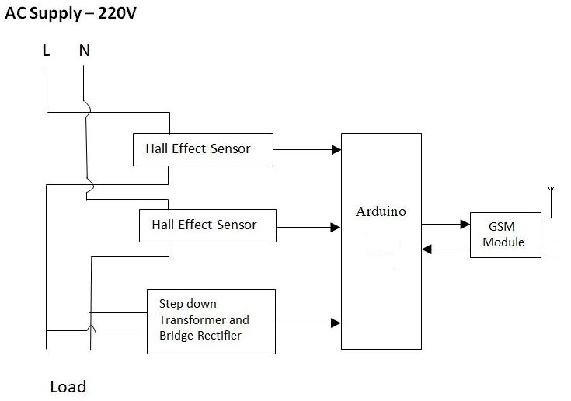

HARDAWARE REQUIREMENT

* ARDUINO
* GSM/GPRS
* Transformer
* Hall effect sensor

SOFTWARE REQUIREMENT

* Arduino IDE